43.60: a) A least-squares fit to log of the activity vs. time gives a slope of
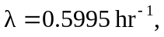for a half-life of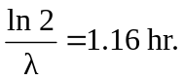 b) The initial activity is 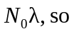
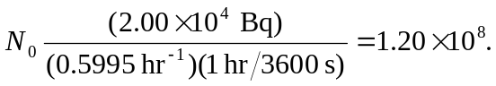
c) 